Annual report International Council for the Exploration of the Sea (ICES)
The International Council for the Exploration of the Sea (ICES) is an intergovernmental marine science organization, meeting societal needs for impartial evidence on the state and sustainable use of our seas and oceans. The ICES convention has geographical coverage of the North-east Atlantic Ocean.
​​​ICES is a network of nearly 6000 scientists from over 700 marine institutes in 20 member countries and beyond. Over 2500 scientists participate actively in ICES activities annually.
In 2021, ICES minted 1879 DOI’s for publications (mainly text and datasets). The publications include expert reports, management advice and management request reports, but also datasets and fisheries overview publications. The number is slightly higher than in 2020.
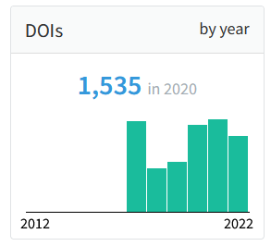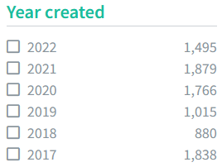
During 2021, ICES has been working towards moving all publication reports to FigShare (https://figshare.com/). FigShare will, on behalf of ICES, be enabled to mint DOI’s within the ICES namespace for DOI’s for publications. Dataset publications will remain as being published by the ICES secretariat. All existing publications will be moved to FigShare during 2022. During this work all web references for the existing report’s will be changed and all issued DOI’s will have to be updated accordingly.

